UNIT OF INQUIRY 1
 | Central Idea  Communities work when members follow shared rules and routines.  Key Concepts  Responsibility, Connection, Reflection | Lines of Inquiry  Working and playing together in school  Using and sharing public spaces  Making responsible decisions  Key Vocabulary  Community, organisation, responsibility, rules, routines, public places, bank, market, post office, library, swimming pool, supermarket, parks, outdoors.
UNIT OF INQUIRY 2
 | Central Idea  People express themselves through different forms of visual arts.  Key Concepts  Form, Perspective | Lines of Inquiry  The different ways artists express themselves  Techniques used in art  Different styles of world art  Key Vocabulary  Colour, shades, clay, artist, expression, sculpture, design, techniques, emotions, feelings.
LANGUAGE
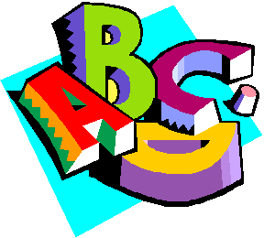 | Reading  Children will read individually and within a guided reading session weekly  Non-Fiction:  Reading and looking at non-fiction books to find information  Identify the features of a non-fiction text and compare to fiction.  Explore different types of nonfiction texts ie leaflets  Fiction:  Explore known/familiar stories  Variety of Traditional and fairy tales  Phonics, Spelling and Vocabulary  Shows an awareness of sound-symbol relationships  Daily phonics sessions in differentiated groups (Letters and Sounds Phases 2-3)  Can apply learnt phonemes, graphemes and tricky words in writing.  Tricky and High Frequency words  Learn to read and write Phase 2, 3 and 4 tricky words according to ability and use them in simple sentence construction | Writing  Write sentences using capital letters, full stops and conjunctions to join ideas.  Fiction:  To be able to organise and discuss simple story structure.  Write and discuss simple stories based on familiar books independently.  To use a range of vocabulary associated with storytelling.  To begin to understand and use story structure ie ‘once upon time’  Non Fiction:  Recount - Recall and record personal events orally and in writing.  To Inform - To collect and present information about different communities (home/school)  Handwriting  Practise individual letters, learning different joins using cursive script  Grammar and punctuation  Building sentences using capital letters, full stops, finger spacing correctly and conjunctions  To identify past and present tense ands begin to use in writing.  To use adjectives to add detail.  To write a label or caption  Sequence information in time order in a logical way.
MATHS
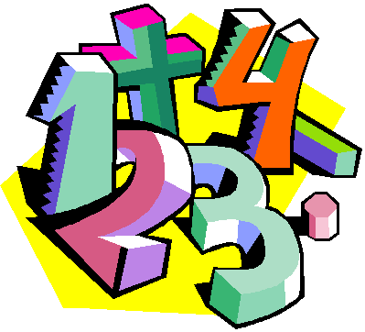 | Integrated Maths  Number and Place Value  Model numbers to one hundred using using concrete materials and the base 10 place value system.  Count to and across 100, forwards and backwards, beginning with 0 or 1, or from any given number.  Measurement  Money: Recognise and know the value of different denominations of coins and notes.  Shape and Space  Recognise and name common 2D shapes (e.g. rectangles including squares, circles and triangles) and 3D shapes (e.g. cuboids including cubes, pyramids and spheres) in different orientations and sizes.  Represent ideas about the real world using geometric vocabulary and symbols, e.g. through oral description, drawing, modelling, labelling.  Data Handling  Block graphs: Collect, represent and interpret data in simple pictograms, tally charts, block diagrams and tables.  Pictograph: Create pictographs and tally marks.Create living graphs using real objects and people. Describe real objects and events by attributes. | Stand Alone Maths  Number and Place Value  Numbers to 100.  Counting forwards and backwards in 1s, 2s,  5s and 10s.  One more, one less.  Addition  Subtraction  Number  Addition & Subtraction:  Use the language of addition and subtraction, e.g. add, take away, plus, minus, sum, difference.  Model addition and subtraction of whole numbers.  Represent number bonds and related subtraction facts within 20.
ICT
 | Integrated ICT:  Investigating:  Use the internet to find simple information  Creating:  Use labelled pictures to share new learning  Communicating:  Record and present information using a camera (e.g.photos and video)  Collaborating:  Use tools to support collaborating with peers. Sharing iPads to use apps. Taking turns on the IWB to play games /use website  Creating:  Can find most letters on the keyboard  Organising:  I can print my documents | Stand Alone ICT  Responsible Digital Citizen:  Use the IT equipment responsibly  Responsible Digital Citizen:  Ask parents and teachers for permission before using the internet
ART
 | Drawing and sketching  Pencil skills- create shapes, lines, patterns, and focus on size.  Explore how these can be organised together to create a piece of art.  Artist : Hundertwasser- shapes and patterns found in his artwork and buildings. Joan Miro- lines to create an artwork  Introducing the art room- things to find out and equipment use.Rules etc. | Painting  Colour mixing, using paint and brushes.  Primary colours and colour mixing.  Different artist styles. Brush strokes-Van Gogh,  Claude Monet, Georges Seurat.  Aboriginal dot painting  Using different resources to paint with.
FRENCH
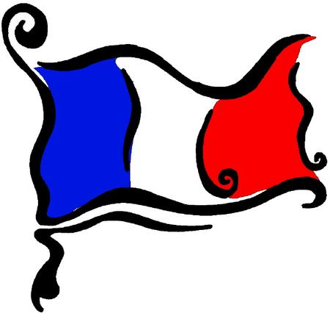 | Introduce family members -  Qui est dans ta famille? Who is in your family. How many brothers/sisters do you have?. Numbers to 10 and beyond  Colours - Les feux d’artifice/Arc en ciel  Parts of the body - songs and rhymes | Listen to stories and songs related to Christmas  Recognise familiar language in Winter stories -  ‘ Le bonhomme de Neige’, Froid, blanc.  ‘L’echarpe la plus longue du monde’, days of the week, colours.

MUSIC
 | Within unit  T1A: The class as a small music community: how should we use the music classroom as a shared space during or out of music lessons?  Developing habits and attitudes towards the proper use of instruments, safe use of electrical instruments and amps; the use of headphones for non-music class purposes.  T1B: Famous paintings that were inspired by music, and famous music pieces that were inspired by paintings. | Stand alone  Singing: songs from the jack and the Beanstalk series. Sing songs, in unison and two parts,  with clear diction, control of pitch, a sense of phrase and musical expression  Instruments, rhythm skills: tempo, beat, keeping in time and long/short.  Learn play several note lengths on percussion instruments: eighth, quarter and half notes, as well as half rests.  Start learning related music symbols.  Preparations for the Winter Show
PE
 | Movement Composition  Students will begin to develop throwing, catching, bouncing and kicking skills with an emphasis on improving hand-eye coordination. They will work independently and in pairs to practice these skills and will start to apply them in small games. | Health- Related Fitness  Students will participate in a range of running and relay activities to develop their speed, endurance and agility. Through these activities, they will begin to develop an understanding of how our body changes during exercise. Continuing to develop spatial awareness and locomotion skills is also an important aspect of PE in Year 1.

